**SAP BW/BO Exercise**

**Exercise – 11: Report Design & Analysis using Web Intelligence**

**Student Name: MANISH BORDOLOI Student Id: M5UTD-005**

**Date: 7/23/2015 BO Explorer Login ID:** **S379-005**

Please use the screenshots ONLY as a reference. The instructions have to be followed AS-IS.

**Objective:**

Task 1: To design a report that demonstrates the concepts of slicing, dicing, drill-across using tables and charts. Task 2: Enhance the presentation of a report by using breaks, sections, sorts, formulas and alerts.

Task 1:

1. Log In to Business Objects BI launch pad by supplying User Name and Password.

1-1 Start the BI Launchpad using instructions provided by your instructor. Log in using your assigned username and password. Depending on the system settings, you may be provided an initial password that you will change.

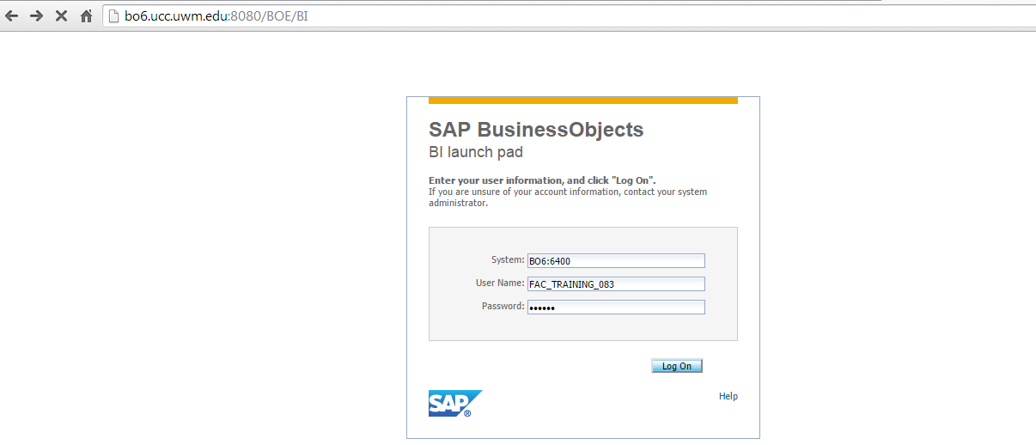

1-2. Create a new Web Intelligence document by clicking on the Application button (in the toolbar) and selecting Web Intelligence (as shown below)





1-3. Select Bex and confirm with OK Button.



a. Select on the left hand side the folder “Common Connections”. Select your connection. (as shown below) (Please wait, if the BW system contains a lot of data, it could take up a few minutes until the available queries are listed.)

b. Select on the right hand side the query “MU8QUERY1” and confirm with OK Button. (as shown below)

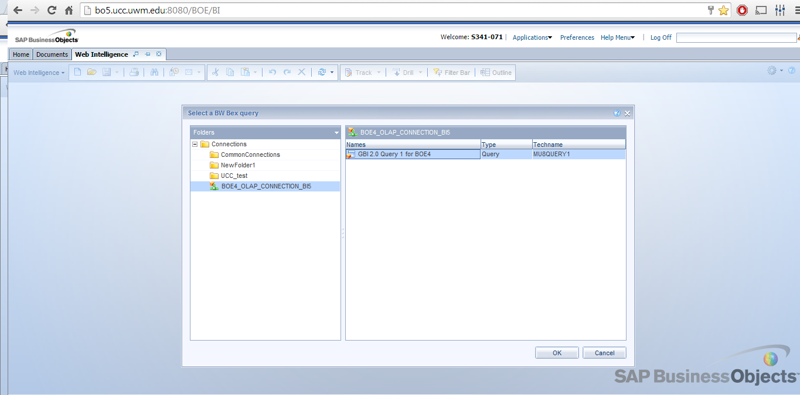

1-4. Create a new query

a. Drag the Calendar Year, Calendar year/month and Customer dimension objects into the Result Objects pane (as shown below).

b. Drag the Revenue measure object into the Result Objects pane.

c. Click Run Query.

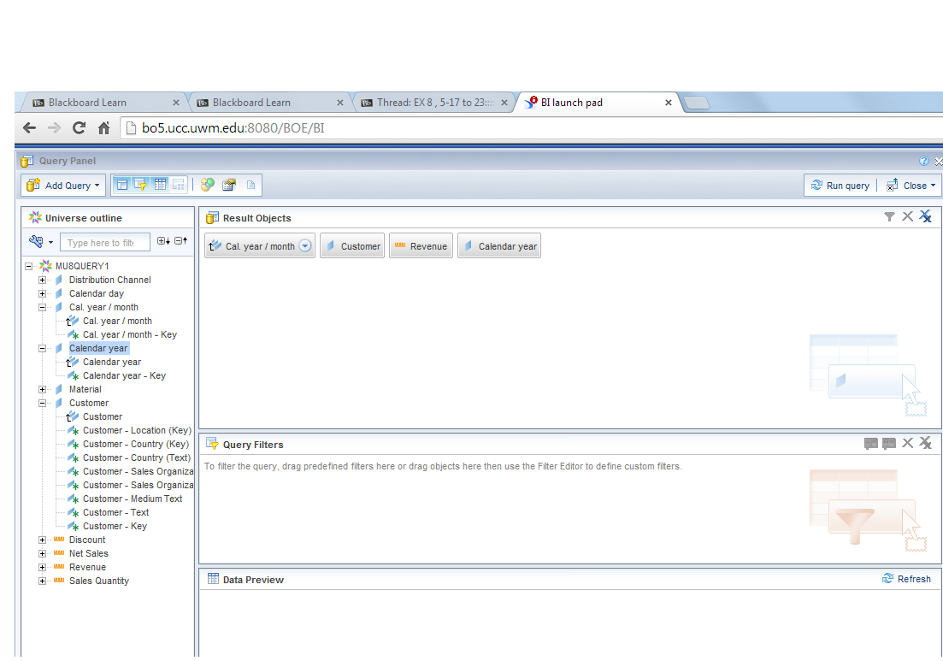

An SQL query is now sent to the database to retrieve data mapped to objects that were selected. Information is returned as a Micro cube also called Data Provider. This information is displayed as a simple table in the Report (as shown below). Resize the column if the values are equal to “###”.

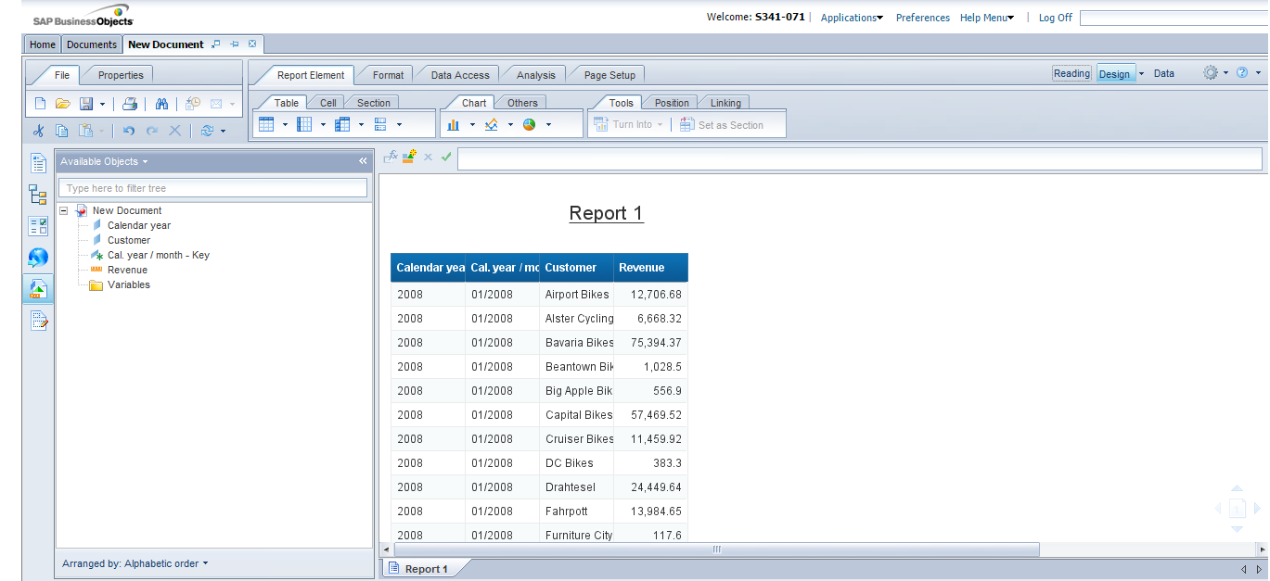

1-5

Paste your screenshot _________________________________________

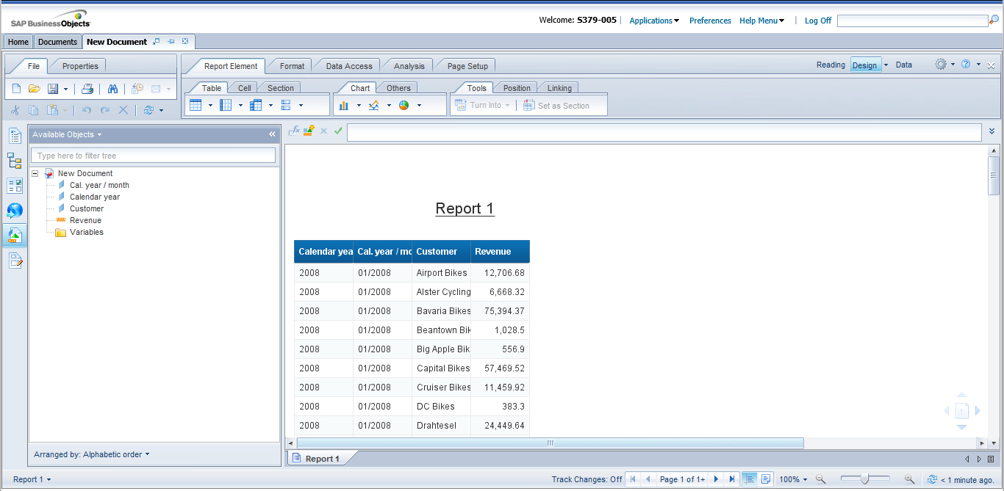

**2) Slicing** is the act of applying a filter to create a slice of data.

Explore the concept of slicing by viewing Revenue data for Year 2010 only.

1. Right-click on the Calendar Year column. Select Filter and click on Add Filter (as shown below).



2-2. Create a filter to restrict the revenues for 2010 only by...

a. Choose Equal to operator from the drop-down list (as shown below)



b. Choose 2010, click on the arrow button (Selected Values) and submit with the OK button (as shown below).



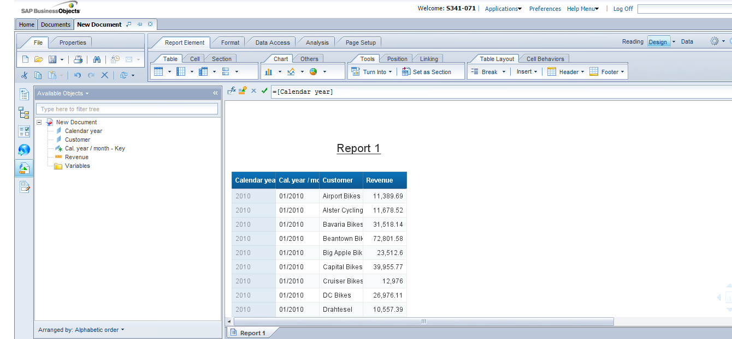

2-3) Paste your screenshot__________________________

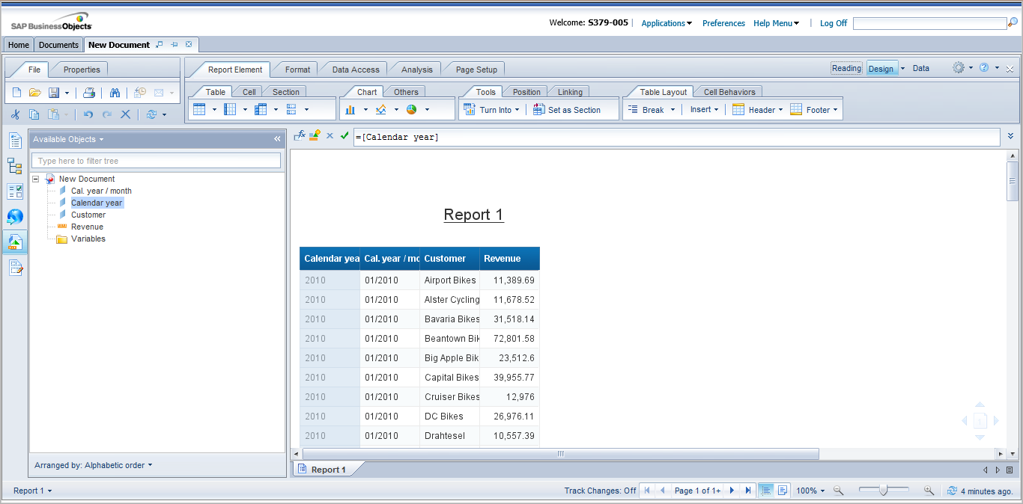

**3) Dicing**

**Dicing** is the act of applying a filter on more than one dimension to create a smaller subset of data.

Look at the concept of dicing by viewing Revenue data for Year 2010, **Month of June** only.

1. Right-click on the month column. Select Filter and click on Add Filter.

2. Create another filter to view revenues for year 2010, month JUN only.

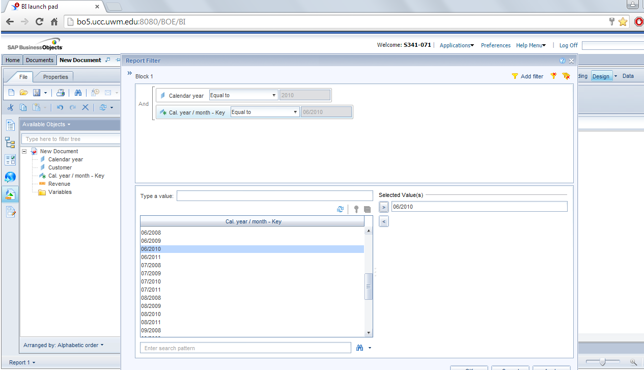

3. Click on OK button.

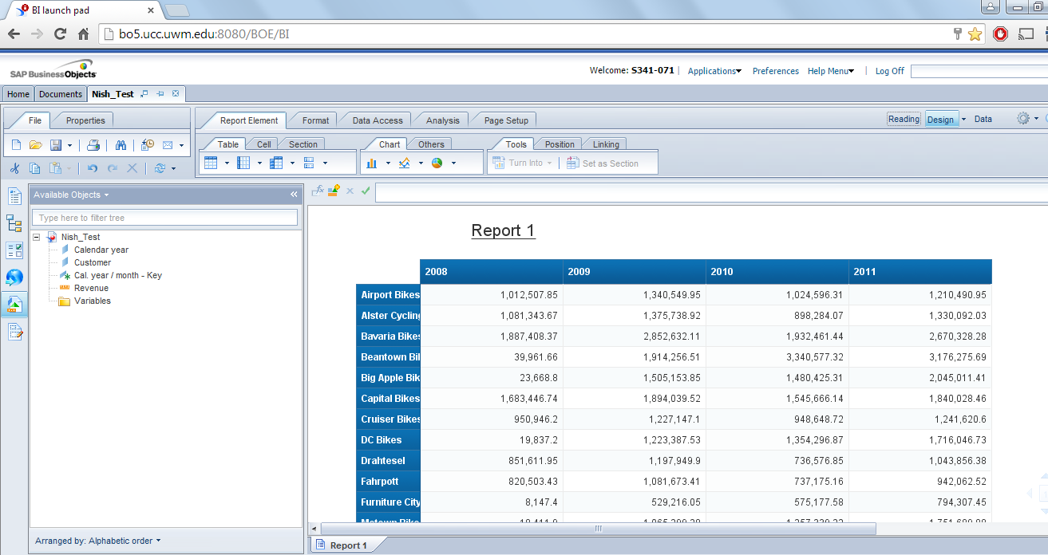

3-4 Paste your screenshot____________________________

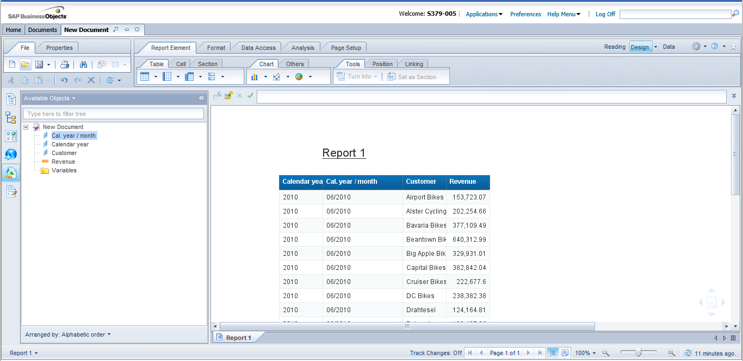

4) **Cross Table**

Drilling Across involves switching the axes. By default, data in the Report View is shown in a Vertical Table format. You need to remove the filters, convert the Vertical Table into a Crosstab and then switch the axes.

* 1. Right-click on the Calendar month column. Select Filter and click on Remove Filter.



4.2 Right-click on the Calendar year. Select Filter and click on Remove Filter.



4.3 Remove the Calendar Month column from the Vertical Table by dragging the column and dropping it into the Objects area (as shown below).





4.4 Convert the Vertical table to a Crosstab by selecting the Vertical Table, right-clicking and choosing Turn Into. Select Crosstab. (as shown below)





4.5 Switch the axes by dragging the Calendar Year column header and dropping it onto the Customer row header (as shown below).

Report with switched axes should as follows:



4.6 Drag the Calendar Month dimension object (from the Objects area) and drop it onto the Customer column header in the Crosstab. The result should be as shown below. What does the analysis now show?

🡪 This shows up the monthly purchases by each of the Customer shown prior to dragging the calendar month into the report.

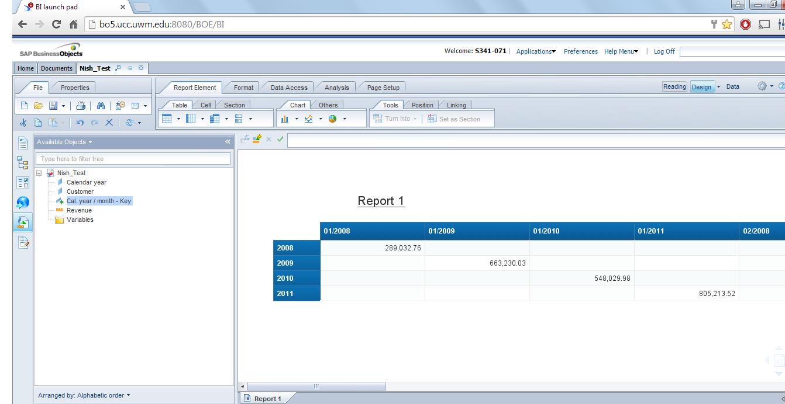

4-7 Paste your screenshot_________________________

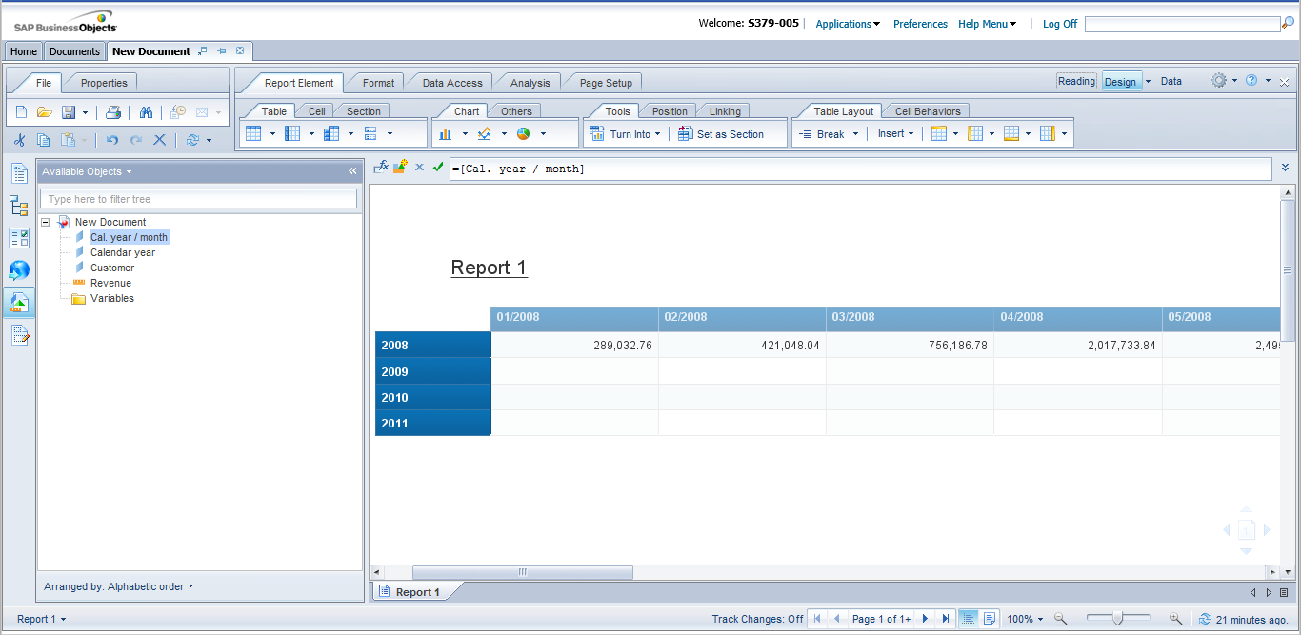

**Task 2:**

You will learn features that will help enhance the presentation of your reports. These features include the use of Breaks and Sections to logically group data in tables and reports respectively. They also include the use of Charts and Rules to add more visual elements to a report.

**5) Breaks**

**Breaks** allow data in tables to be broken up into groups. Using Breaks has 2 main advantages...

a) You can more efficiently organize how your data is represented and

b) You can display subtotals

5-1)

1. Create a new Web Intelligence document.

2. Drag the Calendar Year, Cal year/month and Customer dimension objects into the Result Objects pane (as shown below).

3. Drag the Revenue measure object into the Result Objects pane.

4. Run the Query.



5-2. Insert a Break on the Calendar Year column by

a. Right-click on the year column. Select Break and click on Add Break.(see following figure)



5-3 Paste your screenshot_____________________________________________

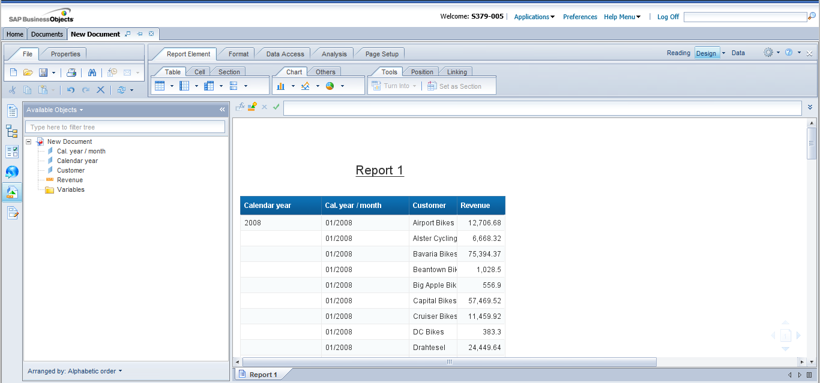

6. Create a **Custom** **Sort** on the Calendar Month column by

|  |  |
| --- | --- |
| a. | Select the Calendar year/ Month column |
| b. | Click Analysis, choose Display. Click Sort button and select Manage |
|  | Sorts.(see following figure) |

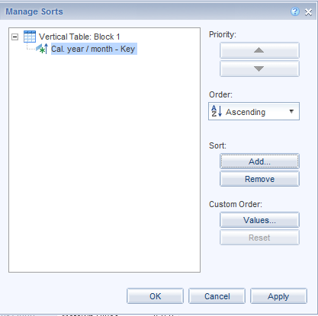

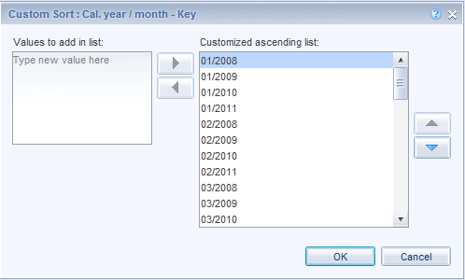

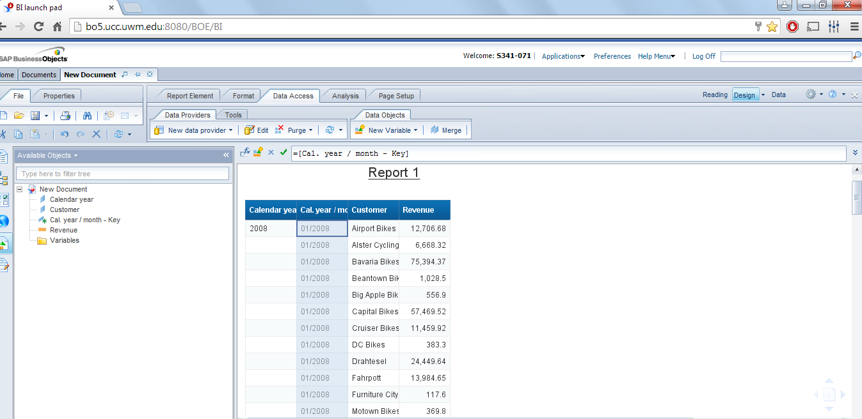

6-2. Insert another Break on the Calendar Month column (see below)

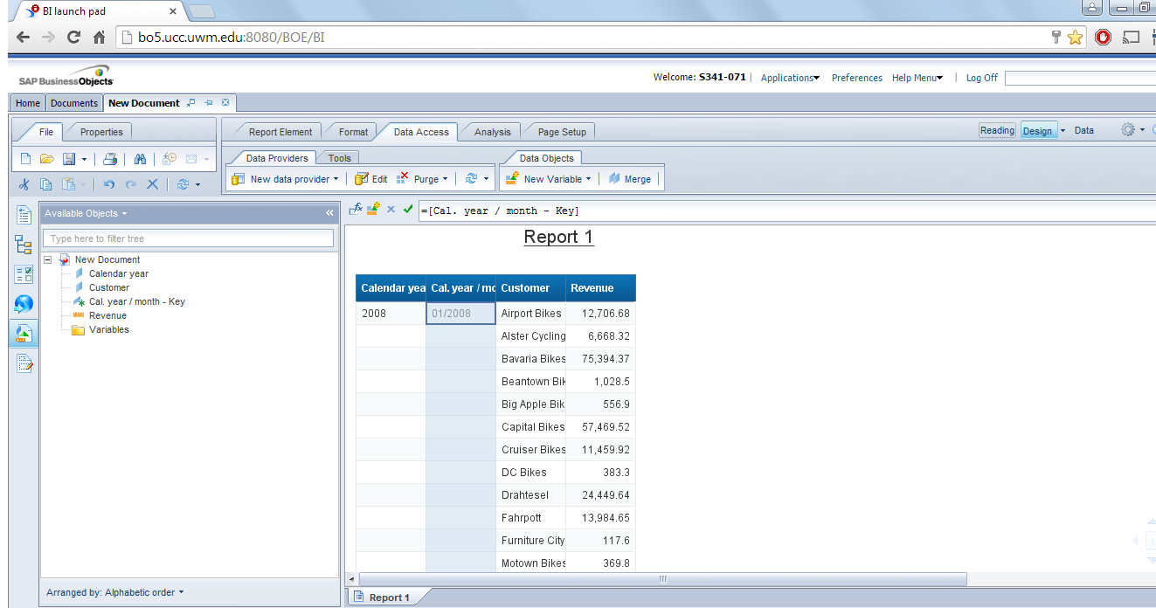

**7. Standard calculations**

**Standard calculation** functions (SUM, AVG, COUNT, MAX, and MIN) allow quick calculations to be made on data.

7.1 Right-click on the Revenue column. Select Insert and click on Sum. (See following figure)



7.2 Right click on the Calendar month column. Select Insert and click on Count.

Notice the Sum and Count values that have been inserted for Revenues for each month of the year (for all customers).

7.3 Paste your screenshot___________________________________________

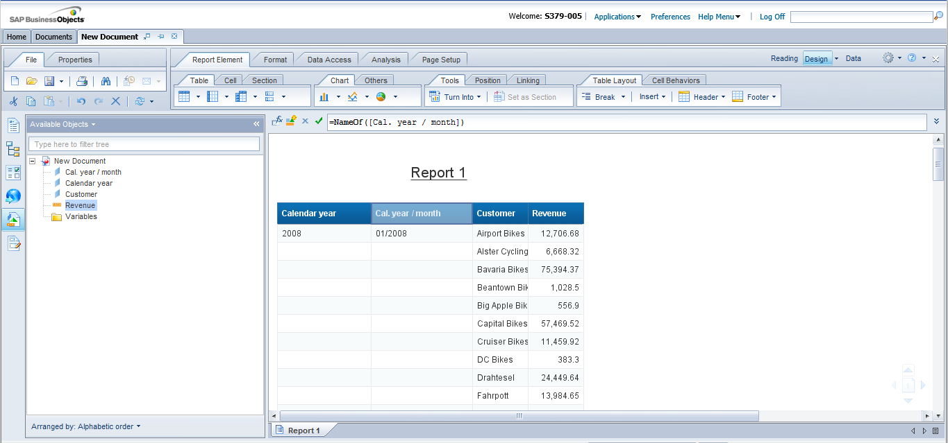

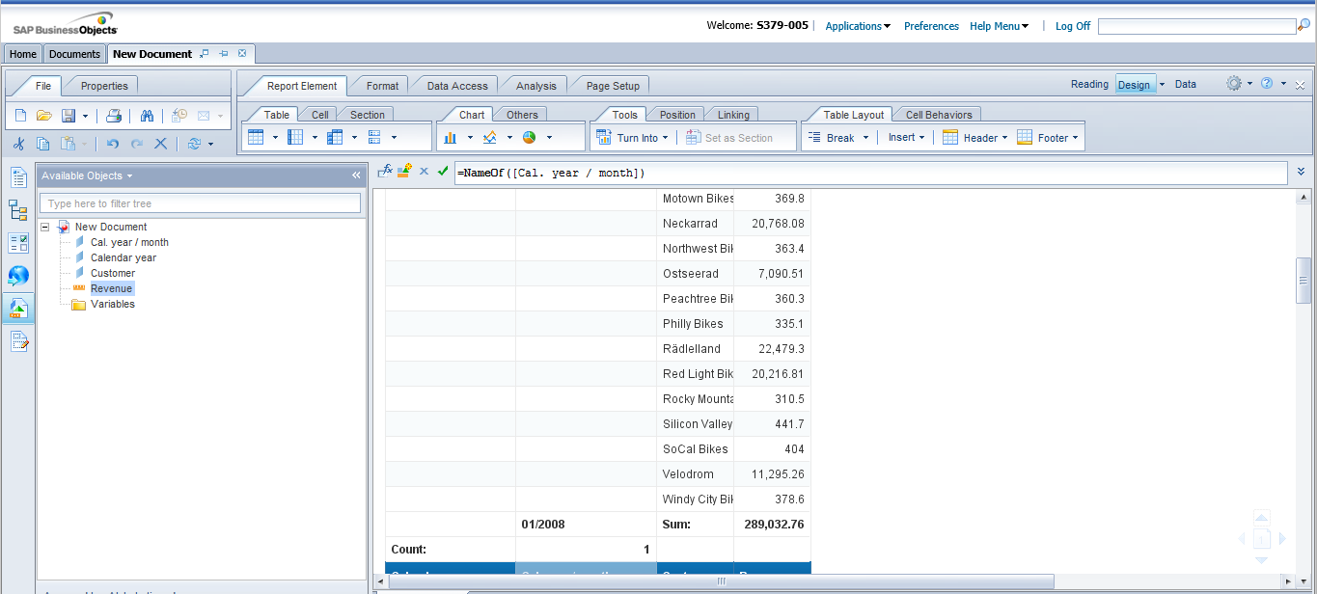

Based on the results of your screenshot, answer the following questions:

Q1: What is the total sum of the Revenues for January 2008?

* **$ 289,032.76**

Q2: What is total count of customers for January 2008? (Hint apply count on Customer Field)

* 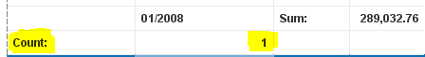

Q3: What is Revenue of Bavaria Bikes for the month of February 2008?

🡪 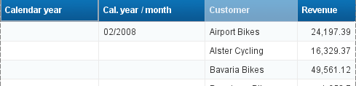

**Bavaria Bikes revenue for Feb, 2008 🡪 $ 49,561.12**

7.4 Remove the All breaks a. Right-click on the Calendar month column. Select Break and click on Remove All Breaks (see following figure)



7.5 Delete the rows containing the Sum and Count values (as shown below)



**8. Sectioning**

Sectioning can also be used to group data. A break only groups data within a block whereas sectioning groups the entire report.

Sectioning has a number of advantages:

a) You can have multiple blocks within a single report, all sub-grouped to the sectioned level

b) You can insert sub-total cells, repeated in each section

8.1 Select the values in the Country column. Right click and select **Set as Section** (as shown below)



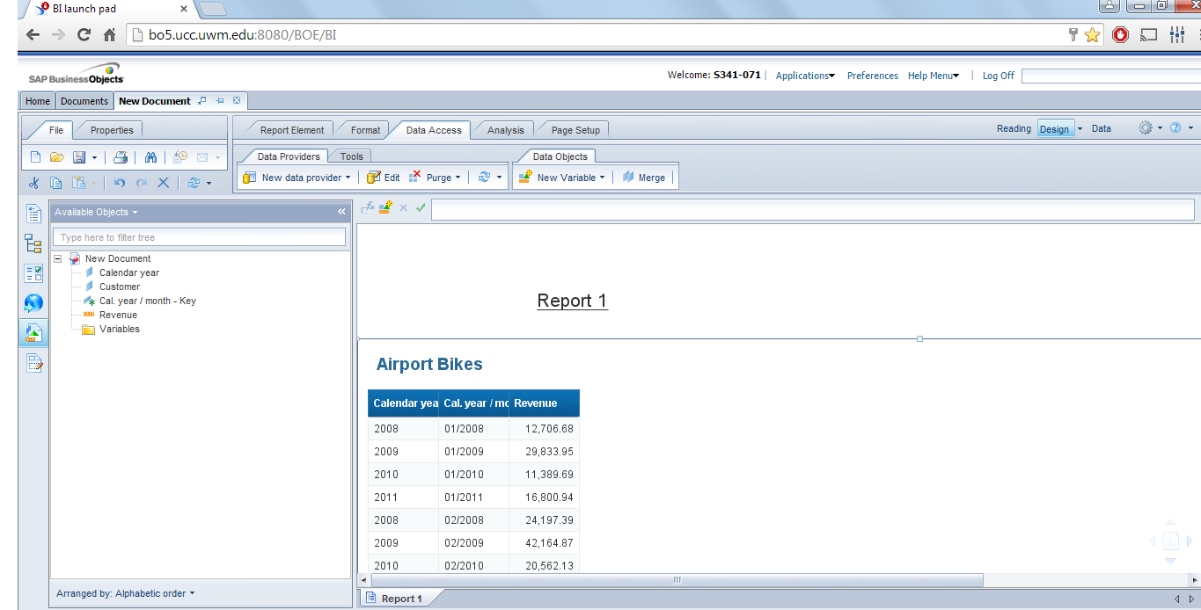

8.2 Click on Report Element. Choose the Listbox “Insert Column Chart” and select More Column Charts (as shown below)



8.3 Drag Vertical Grouped to the report area and drop it to the right of the data table (as shown below)



8.4 Click on Report Element. Choose the Listbox “Insert Column Chart” and select More Column Charts (as shown below)



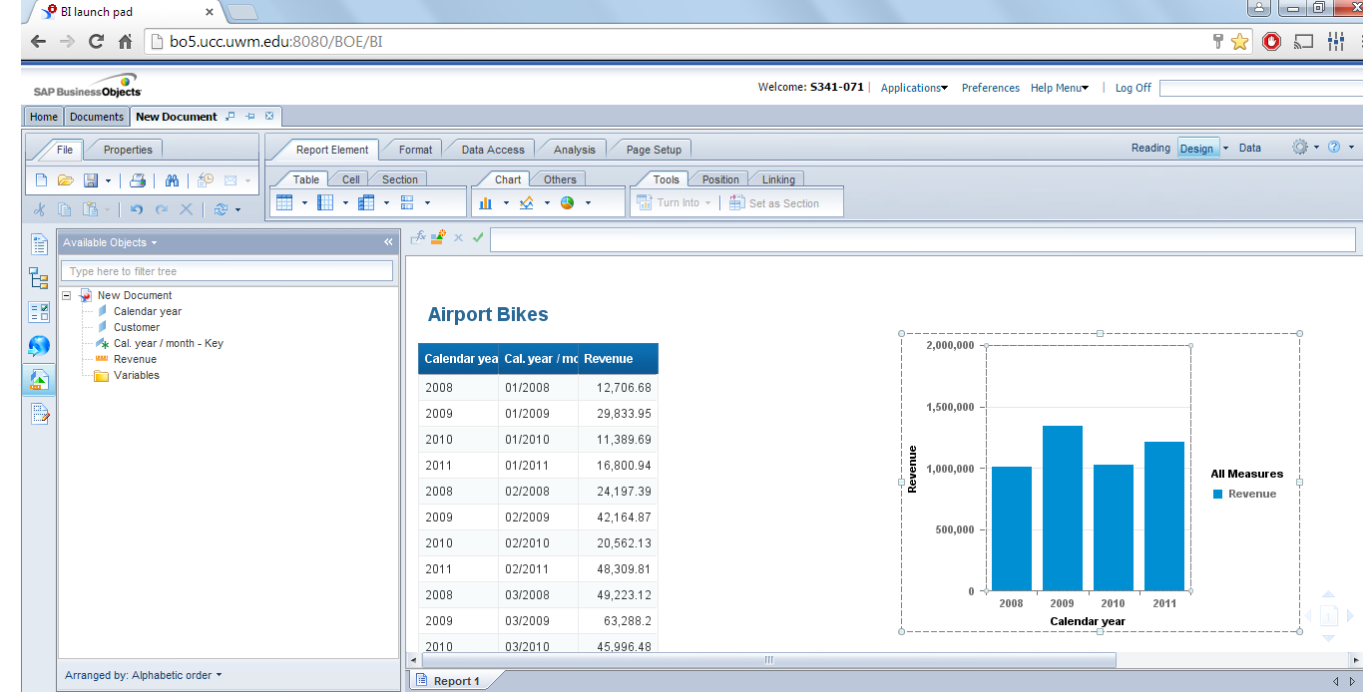

8.5 Paste your screenshot___________________________________________

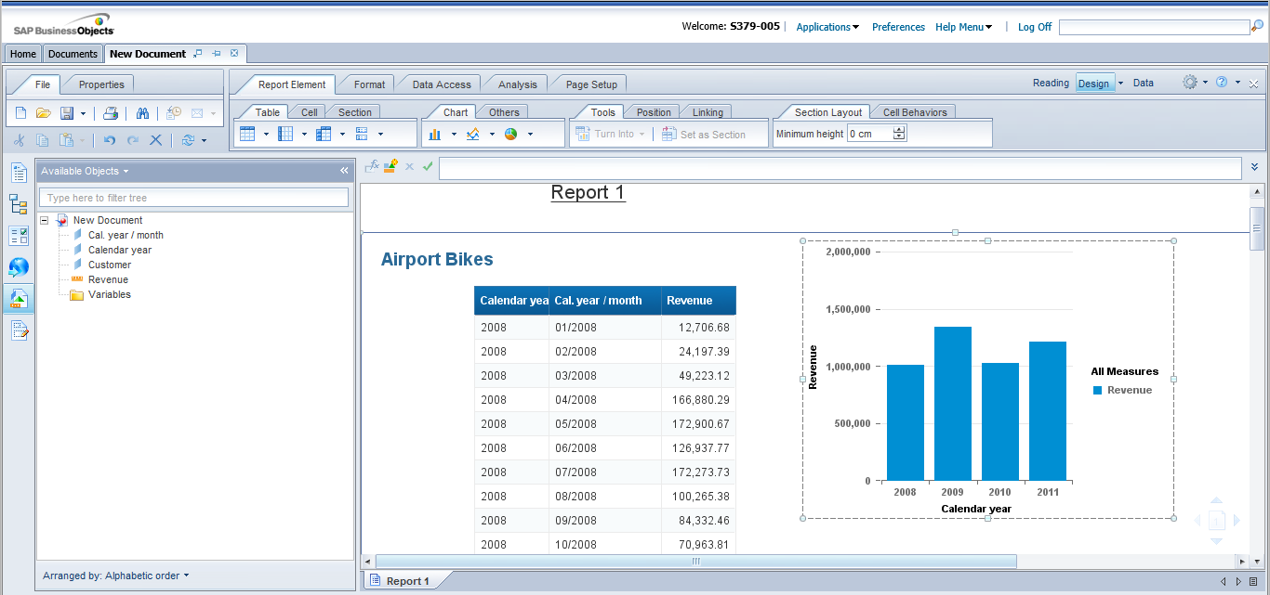

8.6 Sectioningalso allows easier navigation in a long report. Report Map can be used to quickly move to a section in the report.

1. Click on the Report Map.

2. Expand Report 1 and click on Neckarrad to navigate to the last section of the report.

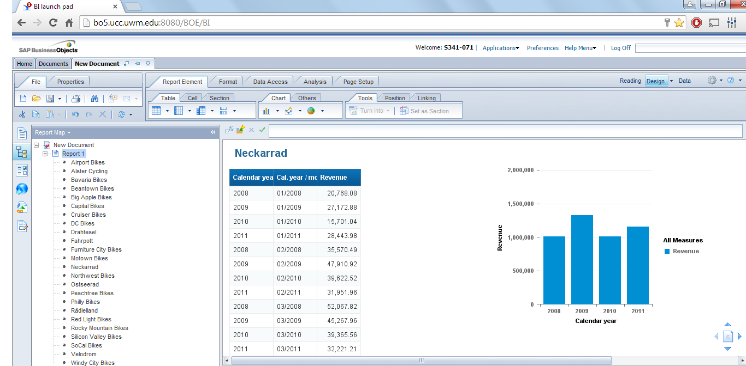

Based on the results of your screenshot, answer the question:

Q4: What is Revenue for Neckarrad for the month of March 2011?

🡪 **$ 50,662.61**

9. **Formulas**

Formulas allow complex calculations to display data that are not available by retrieving existing objects.

Display the Discount per Item (=discount/sales quantity). Create a new Variable and input the formula into this variable.

9.1 Click on Data Access and Edit.



9.2 Add the Sales Quantity and Discount measure objects (as shown below). Re - run the query.



9.3 In the Report Panel, create a new variable named “Discount per Item” by... a. Click on Data Access and “New Variable”

a. Click on Data Access and “New Variable”



b. In the Name field, enter Discount per Item (as shown below)

c. In the Formula field, input the formula: discount / sales quantity

d. Validate the formula and click Ok

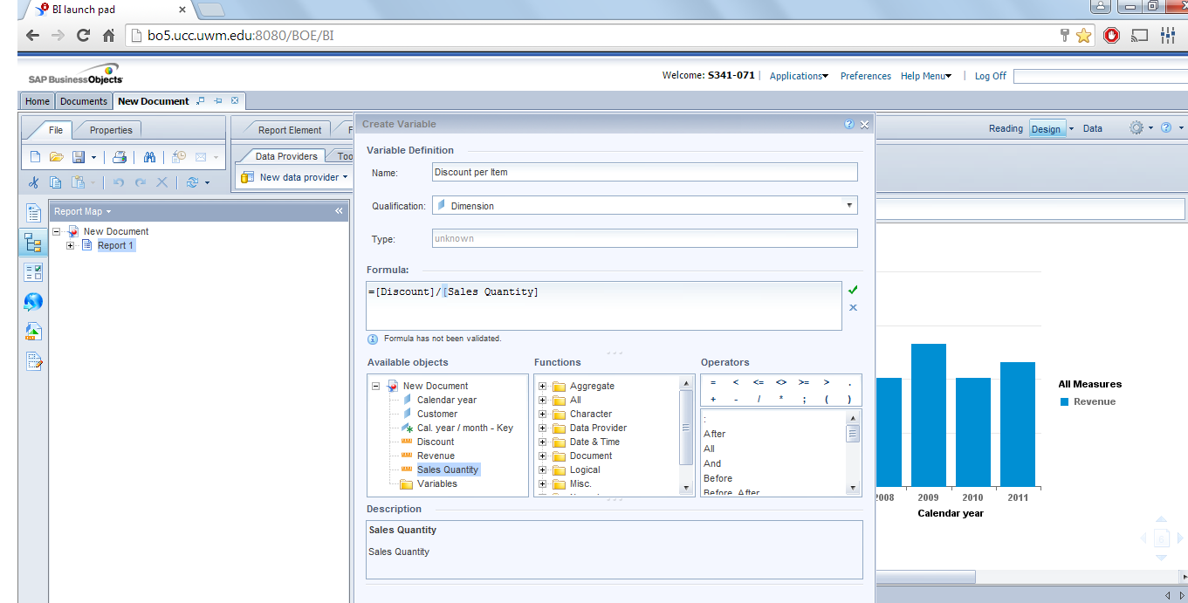

This will create a new Dimension object in the Data Tab.

9.4 Drag the new object “Discount per Item” into the report and drop it to the right of the Revenue column (as shown below). Re-position the figures if required.

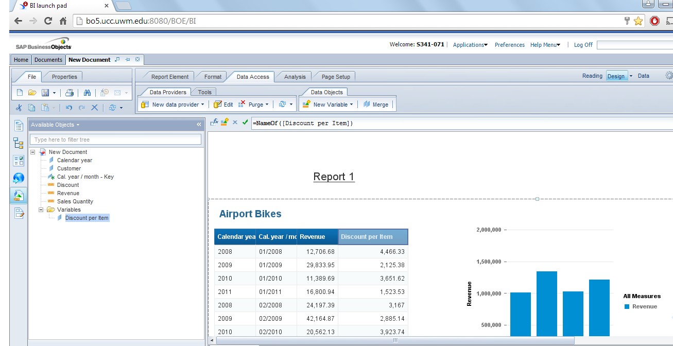

Q5: What is discount per item for the month of January 2009?

* **$ 2125.38**

9.5 Finally, you have to highlight Revenue values that are below a certain figure. This will be very useful to monitor when Revenue is not meeting expectations.

For this purpose, **Rules** in Web Intelligence can be used to set conditions on selected data in the report. Data meeting these conditions are highlighted in different colors to make it easier for the user to see them.

1. Select the Revenue column

2. Click Analysis and Conditional. Select “New Rule”



3. Create the alerter “Sales Revenue Alert” that turns cell contents RED when Sales Revenue falls below 40,000 (as shown below). Click OK.



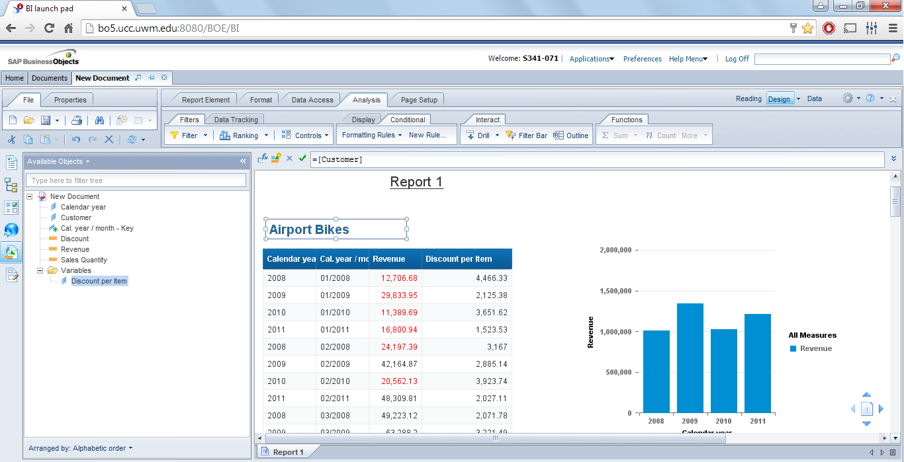

9.6 Paste the screenshot__________________________

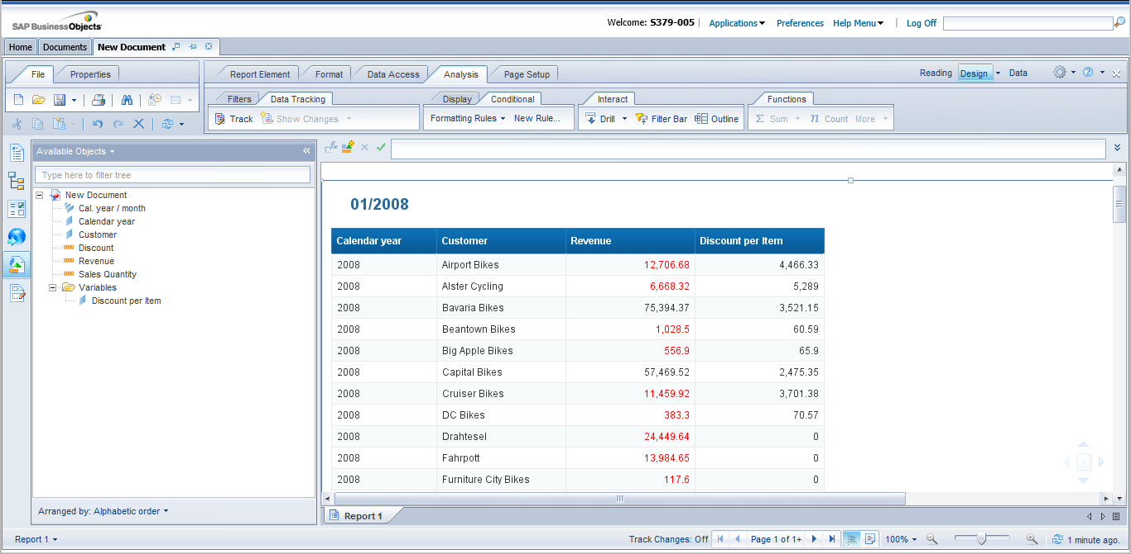

Save the report in “My Favorites” folder as “Task 2 Report”